Chesapeake Bay Roost Scholarship 2026

Capture the Flag Answer Form
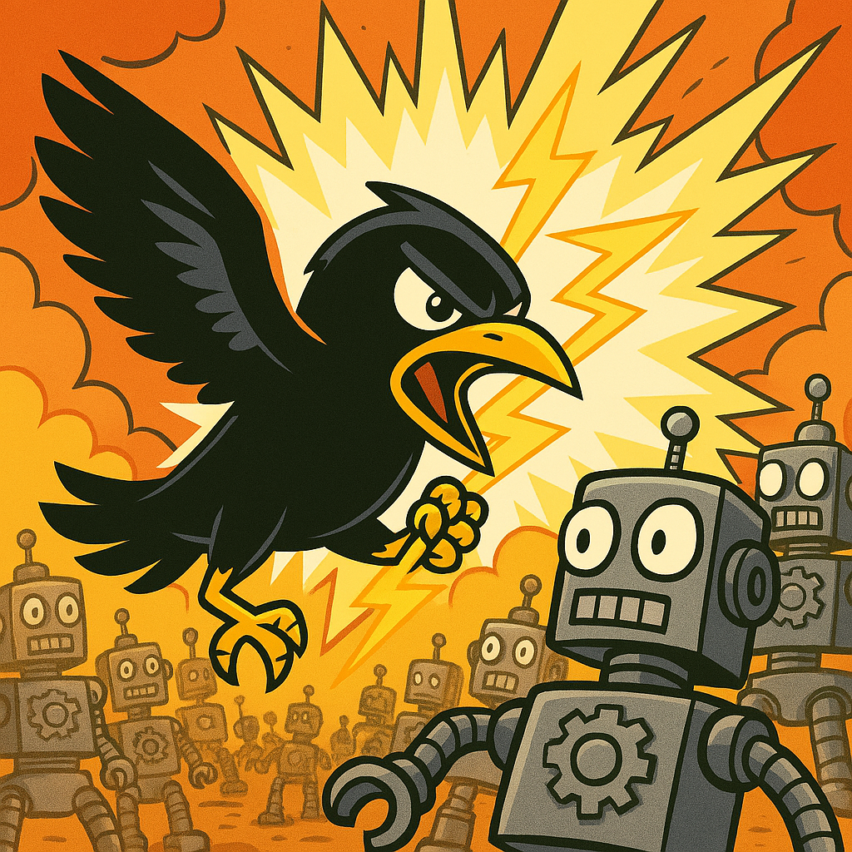

Contact Information

Name:
School:
Phone Number:
Email:
Address:

Answers

Challenge #1: The Spy Within
When will the enemy robot army attack?

Challenge #2: Our Last Hope
Where is the enemy relative to FOB Bravo?

Challenge #3: Interception
What is the access code to bypass the force field protecting the robots' lunar base?

Optional Questions
The following responses will not be considered when determining scholarship recipients. These questions are intended to collect information to improve our scholarship process.

What is your intended major?

How long did you spend on this capture-the-flag exercise?

How can we improve our scholarship and capture-the-flag exercise?

Any other feedback you would like to provide?

